Newsletter
Issue 15

5 January 2024

Dear Parents and Carers,

It was lovely to see all the children back at school this week and eager to tell us all about the exciting things that they did over Christmas. May I take this opportunity to wish you all a happy and healthy New Year.

Year 4
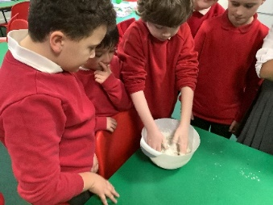
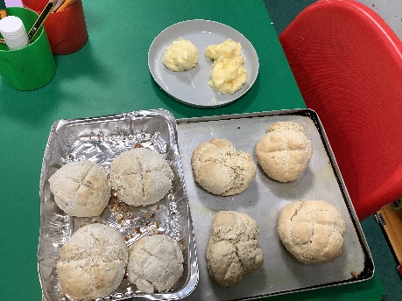
As an introduction to our project on Invaders and Settlers, Year 4 made some bread following an adapted Anglo-Saxon recipe. We then made butter by churning the cream in a jar using a marble as a whisk. The children enjoyed eating the warm bread and freshly made butter.
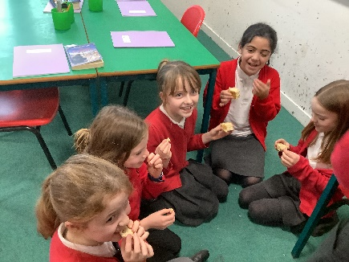

Nut Free School
A reminder that we are a nut free school – this includes all types of chocolate bars, for example Snickers bars. Thank you for your cooperation.

Spanish Lessons
We are pleased to announce that we will be able to offer Spanish lessons at school. These will be run by an outside club and will be taking place on Tuesday lunch times starting on Tuesday 16 January. The cost will be £8.00 per session. For more information go to: www.spanish4kids.co.uk or email: spanish4kidshants@gmail.com or telephone 07971 213619. If you would like to book a trial lesson to give your child a chance to try Spanish club go to: https://spanish-4-kids.classforkids.io

After School Club – advance notice of club closure.
Due to staff training taking place there will be NO After School Club on Wednesday 17 January. School will be open as normal on that day.

Apologies for any inconvenience.

HC3s vacancy
HC3s have some vacancies for mobile catering assistants in the local area.

Please follow the links for more details.

Mobile Catering Assistant - Winchester area - HC3S 614060 (E) (newjob.org.uk)

Mobile Catering Assistant - Winchester area - HC3S 611717 (E) (newjob.org.uk)

Learning Behaviours
We have held this week’s Learning Behaviours assembly. This is where a teacher chooses a child/children that has demonstrated the chosen learning behaviour of the week. The teacher shares with everyone what the child has done and then we all celebrate their achievement. This term we are looking a co-operation. The children who were chosen this week were:

Year One Jack O
Year Two Lolo
Year Three Daisy
Year Four Nina
Year Five Ellen
Year Six Eva

School Lunches
Thank you to everyone for settling their lunch accounts, however the lunch debts are still high - please could you ensure that your account is kept up to date. For your information the money owed per class is as follows:-
Hares £ 154.33
Foxes £ 79.75
Herons £ 170.40
Kingfishers £ 158.20
Nursery £ 135.00

Your child will not be able to order a school lunch if the debt is above £10.00 – if the debt is over £10.00 they will need to bring in a packed lunch. Please can you arrange to clear your Lunch accounts as soon as possible.

If you would like an up to date statement of your child’s account please contact the Admin Team. If you have not yet registered to pay online via Scopay and would like a copy of your login details please email us and we will be happy to help. We would appreciate it if all accounts, including any outstanding Breakfast Club and After School Club accounts, could be settled as soon as possible. Please ensure that your After School Club Account is up to date as we employ extra staff for this club. If you would like an up to date statement please contact the school office.

Thank you for your continued support.

Yours faithfully

Mrs Bordoli
Interim Headteacher
Dates for your diary (new dates in red)

Little Tots in the Hub returns 11 January 2024
Year R school applications close 15 January 2024
No After School Club 17 January 2024
Year 6 residential trip to Calshot 16 - 19 January 2024
Inset Day 19 February 2024
Year 5 trip to Ferny Crofts 24 - 26 April 2024
Inset Day 28 June 2024
Inset Day 1 July 2024

